27.19:
speed at bottom of shaft: 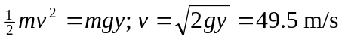
is downward and 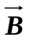is west, so 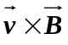is north. Since 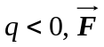is south.

